**Process**

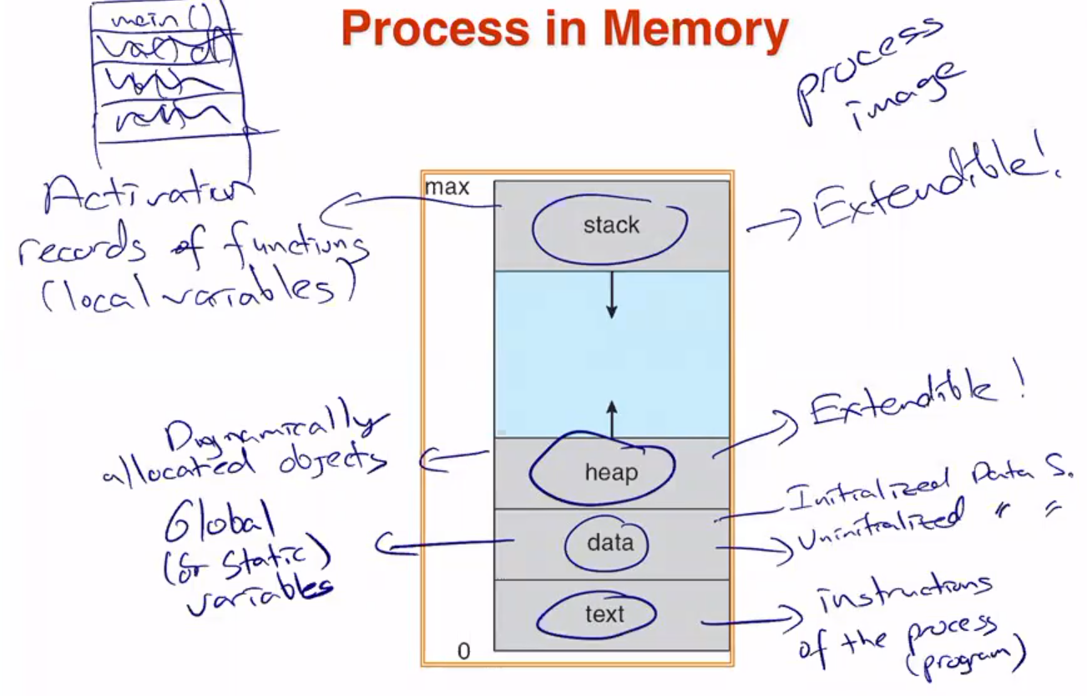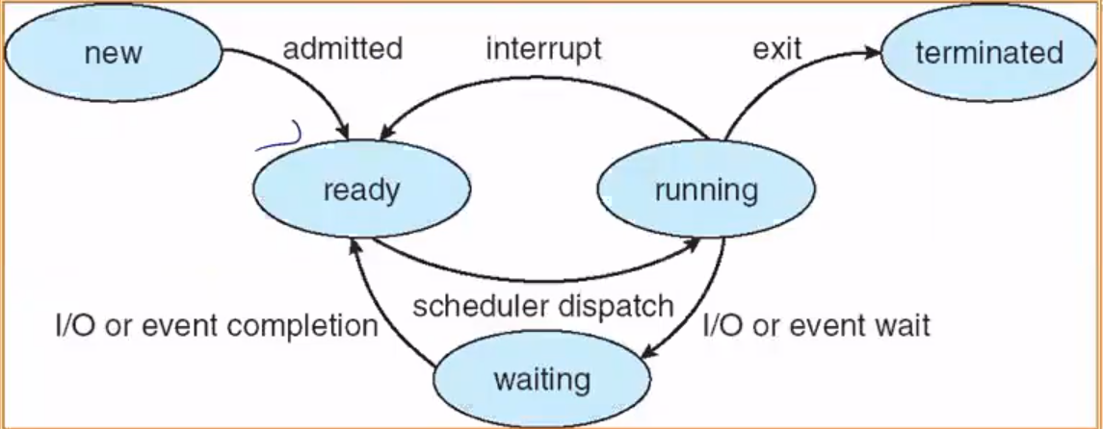

* Processor is faster than I/O
* Swapping: moving part or all of a process from main memory to disk.
  + Blocked state becomes suspend state when swapped to disk
  + **Suspend queue:** Queue of existing process that have temporarily kicked out of MM. (MAIN MEMORY)

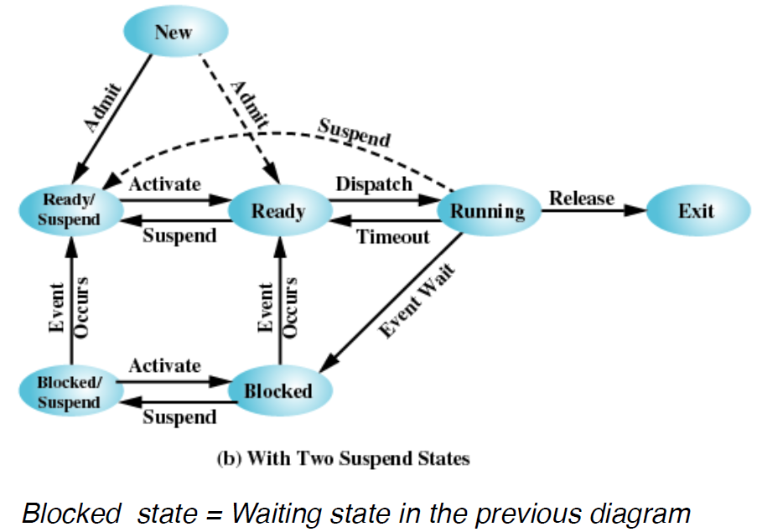

* Reasons of process suspensions:
  + Swapping
  + OS reasons
  + Interactive user request
  + Timing
  + Parent process request

tablo içeren bir resim

Açıklama otomatik olarak oluşturuldu

* **Process Control Block:**
  + **Process identification:** Numeric identifiers
  + **Processor state information:** User-visible registers, control and status registers, stack pointers
  + **Process control information:** Scheduling and state info, data structuring
* **Process Scheduling Queues:**
  + **Job queue:** Set of all processes in the system
  + **Ready queue:** “ “ in main memory
  + **Device queue:** “ “ waiting in I/O device
* **Schedulers**
  + **Long-term scheduler:** Controls the degree of multiprogramming
  + **Short-term scheduler**
  + Processes can be described as:
    - **I/O bound:** Spends more time, many short CPU bursts
    - **CPU bound:** Spends more time, few very long CPU bursts
* **Context Switch**
  + 1. Save current context
  + 2. Change the state of the processor
  + 3. Move it to ready, blocked or ready/suspend
  + 4. Select another proccess for execution
  + 5. Update the process control block of the process selected (change it to running)
  + 6. Update memory management data structure
  + 7. Restore the context of the processor
* **Processes**
  + **Independent**: Cannot affect or be affected by other processors
  + **Cooperating**: Can be affected by other processors.
  + Producer process produces information that is consumed by a consumer process.
    - **Unbounded buffer** – no limit
    - **Bounded buffer** – fixed size
* **Message Passing System**
  + Mechanism for processes to communicate and synchronize their actions.
  + **IPC facility:**
    - send(message), if **direct** 🡪 send(P, message) sends to P
    - receive(message), if **direct** 🡪 receive(Q, message) receives from Q
  + Links are established automatically. Might be undrectional but is usually bi-directional.
  + **Indirect Communication**
    - Messages are directed and received from mailboxes
      * Each mailbox has a unique id
  + **Synchronization**
    - Message passing may be either blocking or non-blocking
    - Blocking is considered synchronous
      * Blocking send – has the sender block
      * Blocking receive – has the receiver block
    - Non-blocking is considered asynchronous
      * Non-blocking send – has the sender block
      * Non-blocking receive – has the receiver block